GSM-BASED DOOR ALERT SYSTEM

# MINI PROJECT REPORT

***Submitted by***

**SARANYA M 2116230701510**

**ATCHAYA S 2116230701045**

**In partial fulfillment for the award of the degree**

**BACHELOR OF ENGINEERING**

***in***

**COMPUTER SCIENCE AND ENGINEERING**

 

**RAJALAKSHMI ENGINEERING COLLEGE**

**ANNA UNIVERSITY: CHENNAI 600 025**

**MAY 2025**

# BONAFIDE CERTIFICATE

Certified that this project **“GSM-BASED DOOR ALERT SYSTEM**” is the bonafide work of “**SARANYA M (2116230701510) and ATCHAYA S (2116230701045)”** who carried out the project work under my supervision.

|  |
| --- |
| **SIGNATURE** |
| **Dr.N.Duraimurugan, M.Tech., Ph.D.** |
| Associate Professor, |
| Computer Science & Engineering |
| Rajalakshmi Engineering College (Autonomous) |
| Thandalam, Chennai -602105. |

Submitted for the **ANNA UNIVERSITY** practical examination Mini-Project work viva voice held on _

**INTERNAL EXAMINER EXTERNAL EXAMINER**

# ACKNOWLEDGEMENT

Initially we thank the Almighty for being with us through every walk of our life

and showering his blessings through the endeavor to put forth this report. Our sincere thanks to our Chairman **Mr. S.MEGANATHAN, B.E, F.I.E.,** our Vice Chairman **Mr. ABHAY SHANKAR MEGANATHAN, B.E., M.S.,** and our respected Chairperson **Dr. (Mrs.) THANGAM MEGANATHAN, Ph.D.,** for providing us with the requisite infrastructure and sincere endeavoring in educating us in their premier institution.

Our sincere thanks to **Dr. S.N. MURUGESAN, M.E., Ph.D.,** our beloved Principal for his kind support and facilities provided to complete our work in time. We express our sincere thanks to **Dr. P. KUMAR, M.E., Ph.D.,** Professor and Head of the Department of Computer Science and Engineering for his guidance and encouragement throughout the project work.

We also extend our sincere and hearty thanks to our Internal Guide **Dr.N.Duraimurugan, M.Tech., Ph.D.** Associate Professor, Department of Computer Science and Engineering for his valuable guidance and motivation during the completion of this project. Our sincere thanks to our family members, friends and other staff members of information technology.

**SARANYA M 2116230701510**

**ATCHAYA S 2116230701045**

# TABLE OF CONTENTS

|  |  |  |
| --- | --- | --- |
| **CHAPTER RNO.** | **TITLE** | **PAGE NO.** |
|  | **ABSTRACT** | **x** |
|  | **ACKNOWLEDGEMENT** | **iii** |
|  | **LIST OF FIGURES** | **vii** |
|  | **LIST OF TABLES** | **viii** |
|  | **LIST OF ABBREVIATIONS** | **ix** |
| **1.** | **INTRODUCTION** | **1** |
|  | 1.1 INTRODUCTION | 1 |
|  | 1.2 SCOPE OF THE WORK | 1 |
|  | 1.3 PROBLEM STATEMENT | 2 |
|  | 1.4 AIM AND OBJECTIVE | 2 |
| **2.** | **SYSTEM SPECIFICATIONS** | **3** |
|  | 2.1 HARDWARE SPECIFICATION | 3 |
|  | 2.2 SOFTWARE SPECIFICATION | 3 |
| **3.** | **SYSTEM DESIGN** | **4** |
|  | 3.1 ARCHITECTURE DIAGRAM | 4 |
|  | 3.2 USE CASE DIAGRAM | 5 |
|  | 3.3 ACTIVITY DIAGRAM | 6 |
|  | 3.4 CLASS DIAGRAM | 7 |
| **4.** | **MODULE DESCRIPTION** | **8** |
|  | 4.1 HARDWARE MODULE | 8 |
|  | 4.2 GSM ALERT COMMUNICATION MODULE | 8 |
|  | 4.3 LCD DISPLAY AND BUZZER ALERT MODULE | 8 |
|  | 4.4 INTEGRATION AND POWER MODULE | 8 |
| **5.** | **TABLES** | **9** |
|  | 5.1 MESSAGE LOG TABLE | 9 |
|  | 5.2 ALERT EVENT TABLE | 10 |
| **6.** | **SAMPLE CODING** | **12** |
| **7.** | **SCREEN SHOTS** | **25** |
| **8.** | **CONCLUSION AND FUTURE ENHANCEMENT** | **26** |
| **9.** | **REFERENCES** | **27** |

# LIST OF FIGURES

|  |  |  |
| --- | --- | --- |
| **FIGURE NO** | **FIGURE NAME** | **PAGE NO.** |
| 3.1 | ARCHITECTURE DIAGRAM | 5 |
| 3.2 | USE CASE DIAGRAM | 6 |
| 3.3 | ACTIVITY DIAGRAM | 7 |
| 3.4 | CLASS DIAGRAM | 8 |
| 7.1 | CIRCUIT CONNECTION OF GSM MODULE WITH ARDUINO | 25 |

# LIST OF TABLES

|  |  |  |
| --- | --- | --- |
| **TABLE NO.** | **TITLE** | **PAGE NO.** |
| 1 | COMPONENT SPECIFICATIONS TABLE | 9 |
| 2 | MESSAGE LOG TABLE | 9 |
| 3 | ALERT EVENT TABLE | 10 |
| 4 | POWER SUPPLY RATINGS TABLE | 10 |

# LIST OF ABBREVIATION

|  |  |
| --- | --- |
| **ABBREVIATION** | **ACRONYM** |
| **IOT** | Internet of Things |
| **GSM** | Global System for Mobile Communication |
| **LCD** | Liquid Crystal Display |
| **AC** | Alternating Current |

# ABSTRACT

The **GSM-Based Door Alert System** is an Internet of Things (IoT) solution designed to enhance home and facility security through real-time intrusion detection and instant alert notification. The system primarily utilizes an **Arduino Uno** microcontroller interfaced with a **GSM module**, **LCD display**, **buzzer**, and other essential components like a **step-down transformer** and **regulated power supply** to ensure stable operation.

Upon detecting unauthorized access or door activity, the system activates the buzzer and simultaneously sends an **SMS alert to a predefined mobile number** using the GSM module. The current status of the door (open/closed) is also displayed on the LCD screen, providing a user-friendly interface. This real-time notification mechanism allows homeowners or administrators to take immediate action, significantly reducing the risk of theft or unauthorized access.

The integration of simple yet effective electronic components ensures affordability and accessibility for both domestic and small-scale commercial use. The project emphasizes practical deployment in areas where internet connectivity is limited or unavailable, as it operates solely on mobile network-based communication.

This mini project demonstrates the powerful potential of GSM-based alert systems in low-cost security infrastructure and paves the way for further advancements such as mobile app integration, solar-powered systems, and sensor-based automation.

# CHAPTER 1

## INTRODUCTION

## 1.1 INTRODUCTION

In today’s world, ensuring the security of homes and restricted zones has become a major concern. With the rise in theft, burglary, and unauthorized intrusions, there is an increasing need for systems that can provide real-time alerts to users. The advent of the **Internet of Things (IoT)** has opened up opportunities to develop smart and connected devices that address this need in a cost-effective and efficient manner.

The **GSM-Based Door Alert System** is a simple yet powerful IoT application that utilizes a **GSM module** for mobile communication and an **Arduino Uno** for real-time processing. Whenever the system detects that a door has been opened or tampered with, it immediately alerts the owner via **SMS** and activates a **buzzer** to signal an intrusion. An **LCD display** shows the current status of the system, offering a clear interface for users.

This system is particularly useful in areas where Wi-Fi or internet connectivity is not available, as it relies solely on GSM-based communication, which is widely accessible. The system can be deployed in homes, shops, offices, and other secure locations to provide instant intrusion detection and alerts.

## 1.2 SCOPE OF THE WORK

The primary scope of this project is to design and implement a **low-cost, GSM-based door security alert system** using microcontroller technology. This system is intended to monitor door status and immediately notify the user when unauthorized access is detected. It is ideal for deployment in homes, hostels, school labs, server rooms, or any place that requires reliable access monitoring.

The system does not require an internet connection, thus making it suitable for **rural or remote areas**. The use of basic components such as **buzzer, LCD, and GSM module** ensures that the overall cost of the system remains low while delivering reliable performance. Future enhancements may include the integration of multiple sensors, app-based monitoring, and camera modules.

## 1.3 PROBLEM STATEMENT

## Conventional security systems are either too costly or depend heavily on internet connectivity, which may not always be reliable. In many remote areas, there is a lack of affordable and effective solutions for real-time intrusion detection. Often, unauthorized access is not discovered until significant damage has already occurred.

## There is a need for a system that can immediately notify the user of any breach, regardless of internet availability. The proposed system aims to solve this problem by using a GSM-based alert mechanism that works effectively even in the absence of a Wi-Fi connection.

## 1.4 AIM AND OBJECTIVES OF THE PROJECT

**Aim:**  
To develop a microcontroller-based **GSM Door Alert System** that can notify users instantly through SMS when the door is opened or tampered with, ensuring enhanced security in offline environments.

**Objectives:**

* To design a GSM-based security alert system using Arduino Uno.
* To interface the GSM module, buzzer, and LCD display with the microcontroller.
* To detect door activity and send SMS alerts to the user.
* To provide visual feedback via the LCD and audible alerts through the buzzer.
* To ensure low power consumption and cost-effective deployment.
* To create a reliable system that works without the internet, suitable for rural and urban use.

# CHAPTER 2

## SYSTEM SPECIFICATIONS

## 2.1 Hardware Specifications

The following hardware components were used to build the GSM-Based Door Alert System:

| **Component** | **Description** |
| --- | --- |
| **Arduino Uno** | Acts as the central microcontroller for handling input/output operations. |
| **GSM Module (SIM800L)** | Sends SMS alerts to the registered mobile number when the door is opened. |
| **Step-Down Transformer** | Converts 230V AC mains to 12V AC required for the power supply section. |
| **Power Supply Unit** | Converts 12V AC to regulated 5V/12V DC to power the Arduino and GSM module. |
| **LCD Display (16x2)** | Displays door status like “Door Opened” or “System Armed”. |
| **Buzzer** | Sounds an audible alarm when an unauthorized entry is detected. |
| **Reed Switch / Magnetic Door Sensor** | Detects door open/close status. |
| **Connecting Wires** | Used to interface all the hardware components securely. |

## 2.2 SOFTWARE SPECIFICATIONS

The development and execution of this project required the following software tools:

| Software | Purpose |
| --- | --- |
| Arduino IDE | For writing, compiling, and uploading code to the Arduino Uno board. |
| Embedded C / Arduino C | Programming language used to control the hardware functionality. |
| SIM800L AT Commands | For sending messages via GSM network through serial communication. |
| Fritzing / Proteus (optional) | For drawing circuit schematics (if used in report documentation). |
| Windows OS | Operating system used for development and programming. |

# 

# CHAPTER 3

# SYSTEM DESIGN

## 3.1 ARCHITECTURE DIAGRAM

An architecture diagram is a graphical representation of a set of concepts, that are part of an architecture, including their principles, elements and components

\ 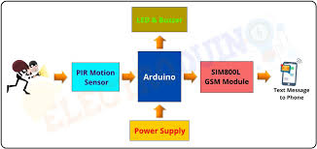

**Figure 3.1** Architecture Diagram

From the above Figure 3.1, the architecture of the system is well understood.

## 3.2 USE CASE DIAGRAM

A use case is a list of actions or event steps typically defining the interactions between a role (known in the Unified Modelling Language as an actor) and a system to achieve a goal. The actor can be a human or other external system.

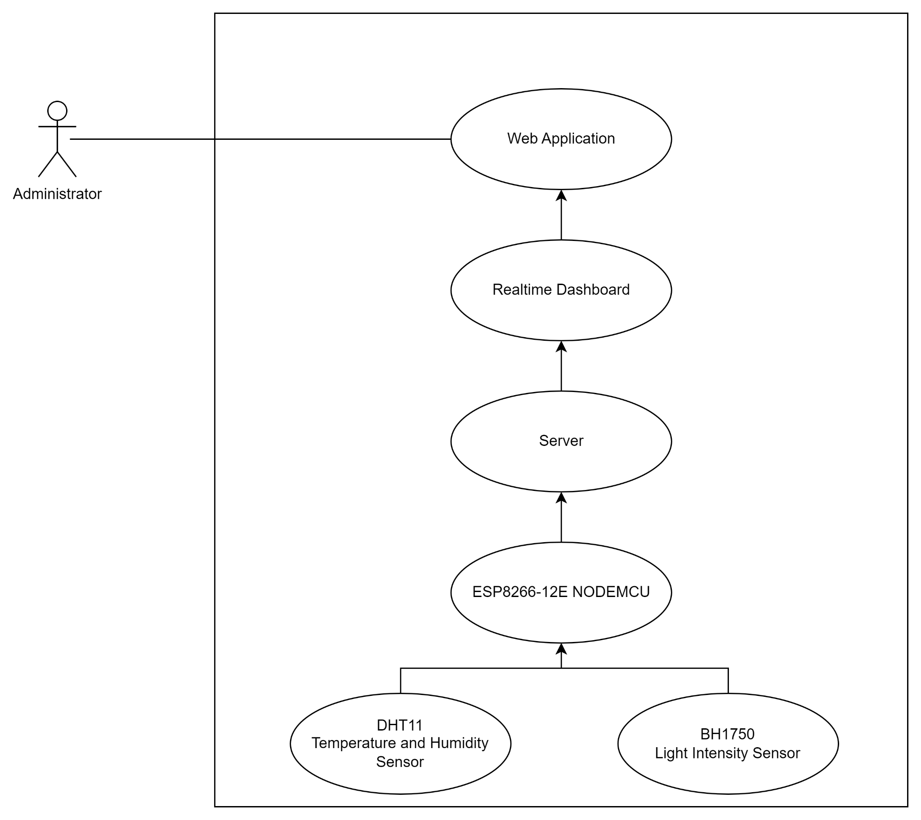

**Figure 3.2** Use case diagram

From the above figure 3.2, the interactions between a role in the system is shown

**3.3 ACTIVITY DIAGRAM**

An activity in Unified Modelling Language (UML) is a major task that must take place in order to fulfill an operation contract. Activities can be represented inactivity diagrams. An activity can represent: The invocation of an operation. A step in a business process.

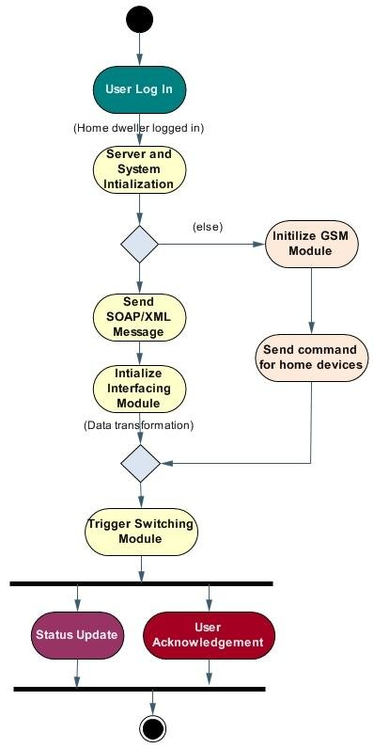

**Figure 3.3** Activity Diagram

From the above figure 3.3, the activities of the system are shown

## 3.4 CLASS DIAGRAM

A class diagram is an illustration of the relationships and source code dependencies among classes in the Unified Modelling Language (UML). In this context, a class defines the methods and variables in an object, which is a specific entity in a program or the unit of code representing that entity.

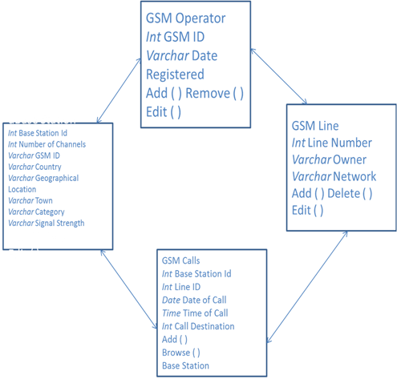

**Figure 3.4** Class Diagram

The above Figure 3.4 is the class diagram for the system.

# CHAPTER 4

# MODULE DESCRIPTION

## 4.1 HARDWARE MODULE:

## This module includes all the physical electronic components responsible for detecting door activity and generating alerts. The Arduino Uno acts as the brain of the system, reading input from the door sensor and controlling outputs like the buzzer, LCD display, and GSM module. When the door is opened, the Arduino triggers an alert process by activating the buzzer and displaying the status on the LCD.

## 4.2 GSM ALERT COMMUNICATION MODULE:

## This module is responsible for sending real-time SMS notifications to the user's registered mobile number through the SIM800L GSM module. It operates based on AT commands and communicates with the Arduino via serial communication. This module ensures immediate user awareness of any unauthorized door access, even in the absence of an internet connection.

## 4.3 LCD DISPLAY AND BUZZER ALERT MODULE:

## The LCD (16x2) module displays system status messages such as “System Armed”, “Door Opened”, or “Message Sent”, providing real-time feedback to the user. The buzzer offers an audible warning whenever the door is opened unexpectedly. Together, they provide both visual and audible alerts that enhance system usability and effectiveness.

## 4.4 INTEGRATION AND POWER MODULE:

## This module focuses on power distribution and signal integration. A step-down transformer converts 230V AC to 12V AC, which is then rectified and regulated using a power supply circuit to feed the microcontroller and GSM module. The integration ensures proper synchronization between sensors, microcontroller, output devices, and communication units for smooth operation of the entire system.

# CHAPTER 5

**TABLE**

## 5.1 COMPONENT SPECIFICATIONS TABLE

| S.No | Component Name | Specification / Model | Purpose |
| --- | --- | --- | --- |
| 1 | Arduino Uno | ATmega328P | Central microcontroller |
| 2 | GSM Module | SIM800L | Sends SMS alerts |
| 3 | LCD Display | 16x2 | Displays door status |
| 4 | Buzzer | 5V Piezoelectric | Audible alert for door open detection |
| 5 | Transformer | 230V AC to 12V AC | Step-down input voltage |
| 6 | Power Supply | 12V AC to 5V/12V DC (regulated) | Provides DC power to circuit |
| 7 | Reed Switch | Magnetic Door Sensor | Detects door status |
| 8 | Connecting Wires | Male-to-Male / Male-to-Female | Hardware interfacing |

## 5.2 MESSAGE LOG TABLE

| **S.No** | **Time Stamp** | **Event** | **Message Sent** |
| --- | --- | --- | --- |
| 1 | 09:15 AM | Door Opened | “Alert! Door opened at 09:15 AM” |
| 2 | 02:30 PM | Door Opened | “Alert! Door opened at 02:30 PM” |

## 5.3 ALERT EVENT TABLE

| S.No | Door Status | Buzzer Status | LCD Message | SMS Sent |
| --- | --- | --- | --- | --- |
| 1 | Open | ON | “Door Opened” | Yes |
| 2 | Closed | OFF | “System Armed” | No |

## 

## 5.4 POWER SUPPLY RATING TABLE

| S.No | Component | Voltage Required | Current Rating |
| --- | --- | --- | --- |
| 1 | Arduino Uno | 5V DC | 50 mA |
| 2 | GSM Module | 12V DC | 2A peak |
| 3 | LCD Display | 5V DC | 30 mA |
| 4 | Buzzer | 5V DC | 20 mA |

**CHAPTER 6**

**SAMPLE CODING**

**6.1 ARDUINO CODE FOR GSM-BASED DOOR ALERT SYSTEM**

#include <SoftwareSerial.h>

#include <LiquidCrystal.h>

const int sensorPin = 2;

const int buzzerPin = 3;

const int rxPin = 10;

const int txPin = 11;

LiquidCrystal lcd(7, 8, 9, 4, 5, 6);

SoftwareSerial gsm(rxPin, txPin);

int doorState = 0;

void setup() {

pinMode(sensorPin, INPUT);

pinMode(buzzerPin, OUTPUT);

lcd.begin(16, 2);

gsm.begin(9600);

Serial.begin(9600);

lcd.setCursor(0, 0);

lcd.print("System Armed");

delay(1000);

}

void loop() {

doorState = digitalRead(sensorPin);

if (doorState == HIGH) {

digitalWrite(buzzerPin, HIGH);

lcd.clear();

lcd.print("Door Opened!");

sendSMS("ALERT! Door Opened!");

delay(3000); // Debounce delay

digitalWrite(buzzerPin, LOW);

} else {

lcd.setCursor(0, 0);

lcd.print("System Armed ");

}

delay(1000);

}

void sendSMS(String message) {

gsm.println("AT+CMGF=1");

delay(1000);

gsm.println("AT+CMGS=\"+919361048283\"");

delay(1000);

gsm.println(message);

delay(100);

gsm.write(26);

delay(1000);

}

**6.2 HOW THE CODE WORKS**

* The **sensorPin** detects door status via a magnetic/reed switch.
* When the door opens, it triggers the **buzzer**, displays the status on the **LCD**, and sends an **SMS alert** via GSM.
* The **sendSMS()** function uses AT commands to send messages through the SIM800L module.

# CHAPTER 7

# SCREEN SHOTS

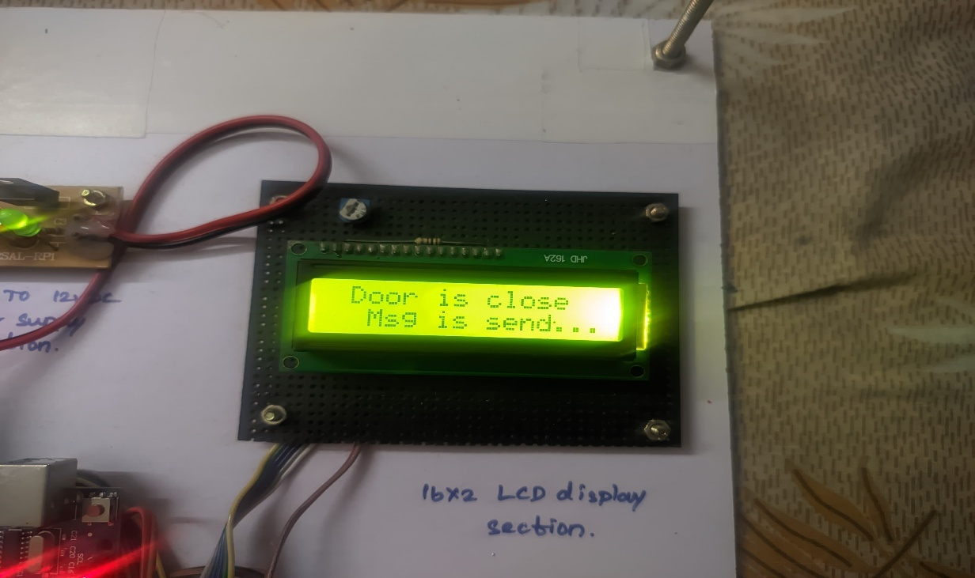

**Figure 7.1** Responsive Dashboard

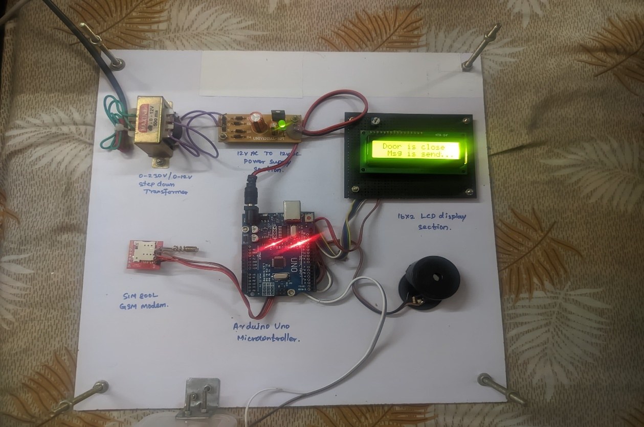

# CHAPTER 8

## CONCLUSION AND FUTURE ENHANCEMENT

The **GSM-Based Door Alert System** is a practical and cost-effective solution that addresses the critical need for real-time intrusion detection and alerting mechanisms in residential, educational, and commercial spaces. This project successfully integrates hardware components like the **Arduino Uno**, **GSM module**, **buzzer**, **LCD display**, and **magnetic door sensor** to form a fully functional security alert system.

The core strength of this system lies in its ability to function independently of the internet. By relying on **GSM-based mobile communication**, it ensures that alerts are delivered instantly to the user’s mobile device, making it highly reliable even in rural or offline environments. The **LCD module** provides user-friendly feedback, while the **buzzer** acts as an immediate audible deterrent to intruders.

Throughout the development process, various technical challenges such as power supply stabilization, GSM signal interfacing, and timing issues were encountered and resolved through experimentation and iteration. The final implementation proved to be robust, responsive, and efficient in detecting door status and triggering alerts accordingly.

The project reinforces the impact of IoT in enhancing everyday safety and demonstrates how **microcontroller-based embedded systems** can be deployed for real-time applications with minimal infrastructure requirements. It not only meets the project’s original objectives but also opens doors for several innovative additions in the future.

# Future Enhancement

# While the current version of the GSM-Based Door Alert System performs reliably, there are several opportunities to enhance its functionality, flexibility, and intelligence:

# Integration with Mobile Application A dedicated Android or iOS application can be developed to provide remote access, arm/disarm control, and alert logs for the user, improving convenience and user experience.

# Battery Backup & Solar Power Introducing a rechargeable battery pack or solar-powered setup would make the system operational during power outages, improving reliability for 24/7 security.

# Multiple Entry Monitoring The system can be extended to monitor multiple doors/windows using additional sensors and assigning zone-specific alerts in the SMS messages.

# Camera Integration By integrating a small camera module (e.g., ESP32-CAM), users can receive image/video footage of the intruder via MMS or cloud storage links along with the SMS alert.

# Cloud-Based Logging Storing all alerts and door activity in a cloud database would allow for historical review and analytics. This could be helpful for audit trails in institutions or commercial use.

# Biometric or RFID Integration Advanced versions can use fingerprint or RFID card authentication to identify authorized access and only trigger alerts for unauthorized entries.

# Home Automation Compatibility With slight modifications, this system can be made compatible with existing home automation platforms like Alexa, Google Assistant, or Node-RED dashboards.

# Tamper Detection Mechanism Future versions could include tamper-proof enclosures and alert the user not only about door activity but also if someone tries to disable the system.

# REFERENCES

1. Banerjee, S., & Kundu, S. (2019). *Implementation of GSM Based Home Security System Using Arduino.* International Journal of Scientific & Engineering Research, 10(2), 101–105.
2. Punit Gupta, Dinesh K. Lobiyal. (2015). *A GSM Based Real Time Security System.* International Journal of Computer Applications, 119(19), 25–30.
3. Shrivastava, A., & Verma, S. (2017). *SMS Based Home Security System Using Arduino and GSM Module.* International Journal of Computer Applications, 161(11), 7–11.
4. Jain, A., & Arora, S. (2020). *Arduino Based Intrusion Detection System Using GSM Module.* International Research Journal of Engineering and Technology (IRJET), 7(3), 2371–2375.
5. GSM Association. (2022). *What is GSM Technology?* Retrieved from: <https://www.gsma.com/>
6. Arduino.cc. (2024). *Arduino Uno Documentation.* Retrieved from: https://www.arduino.cc/en/Guide/ArduinoUno
7. SIMCom. (2020). *SIM800L GSM/GPRS Module Datasheet.* Retrieved from: https://simcom.ee/documents/SIM800L/SIM800L_Hardware_Design_V1.00.pdf
8. Mazidi, M.A., & Naimi, S. (2011). *The AVR Microcontroller and Embedded Systems: Using Assembly and C.* Pearson Education.
9. Sharma, A., & Singh, P. (2020). *GSM Based Smart Alert System for Door Monitoring.* International Journal of Innovative Technology and Exploring Engineering, 9(7), 2334–2339.
10. Prasad, R., & Ranjan, A. (2018). *Design of Low-Cost Home Security System Using Arduino UNO and GSM Module.* IEEE International Conference on Computational Intelligence and Computing Research.